# 

# ITC41 Project Synopsis

Sem IV Batch 2021-23

# “Alumni Connect”

By

“Shubham Sanjay Sahane”

“Roll No: 106”

Under the Guidance

Of

“Prof. Kalyani Alisetty”



# Contents:

1. Project Introduction 3
2. Scope of project. 4
3. Existing System. 5
4. Proposed System. 6
5. Technologies used. 7
6. System Architecture. 8
7. List of modules. 9,10

**Alumni Connect**

# Abstract :

# The AlumConnect System is a Java-based web application designed to connect alumni with their alma mater and current students. The system provides a platform for alumni to stay updated on the latest happenings at their former institution and to contribute to its growth by offering their expertise and resources. The application also allows current students to connect with alumni and seek guidance and support in their career and academic pursuits.

# Introduction :

# Alumni play an essential role in the growth and development of educational institutions. They are a valuable resource for knowledge, expertise, and financial support. However, maintaining a connection with alumni can be challenging, especially when they are spread across the world. The AlumConnect System aims to bridge this gap by providing a platform for alumni to stay connected with their alma mater and contribute to its growth.

# Scope of the System:

* This system can be used as an application for the Alumni Information Database to manage the college information and student’s information.
* The system is an online application that can be accessed throughout the organization and outside customers as well with proper login provided, which will give better service to the customers.
* It is completely automated system in handling the college database
* This system provides centralized database maintenance
* This system provides easy access to the particular students account or his complete details
* This system provides student to easily navigate through the application for more information in a most secure manner.

Existing System:

* Existing system is a manual one in which users are maintaining document’s paper work to store the information like colleges details, student details.
* It is very difficult to maintain historical data.
* It is difficult to maintain important information in documents paper work.
* More manual hours need to generate required reports.
* It is tedious to manage historical data which needs much space to keep all the previous years, ledgers, documents paper work.

Proposed System:

The AlumConnect System is a Java-based web application that provides a platform for alumni to connect with their former educational institutions and current students. The system offers a range of features such as job posting, event management, mentorship programs, and fundraising campaigns. Alumni can use the platform to stay updated on the latest happenings at their former institution, connect with other alumni, and contribute to its growth.

Objectives:

* To build a system that will be able to manage alumni data of a college and provide easy access to the same.
* To reduce manual work.
* To provide user-friendly interface.
* Quick data retrieval and large amount of data storing.
* To allow old and new students of a university or college to communicate with each other.
* This allows students to know about each other and their current activities.

Technologies:

**Front-end technologies:**

HTML5, CSS, JavaScript, Bootstrap

**Back-end technologies:**

**Language & Server:** JAVA/J2EE, Servlet, Tomcat

**Database:** MySQL

System Architecture :

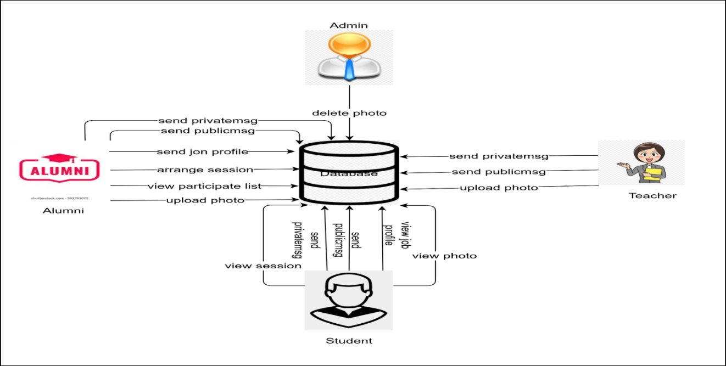

Modules:

**Admin module:**

* Admin can login through username and password in system.
* Admin can add/delete the photos.
* Verify User.
* Manage User.

**Alumni module**:

* Alumni send public message.
* Alumni send private message.
* Alumni send job profile.
* Alumni will Host session.
* Alumni view the participant list.
* Alumni will upload function photos.
* Search Student With Specific interest.
* Share Student Profile.
* Manage Own Profile.

**Teacher module:**

* Teacher send public message.
* Teacher send private message.
* Teacher will upload function photos.
* Manage Own Profile.
* Arrange Sessions for Student.
* View Alumni in Specific organization and Role.

**Student module:**

* Student send public message.
* Student send private message.
* Student will view job profile.
* Student will participate to session.
* Student will view photos.
* Manage Own Profile.